The Conservation Area’s
Strengths, Weaknesses, Opportunities and Threats - Form [Digital]

Rushcliffe Borough Council has developed this tool to help communities contribute in unveiling the special character of an area and identify the features that make it distinctive, interesting and promotes its sense of place.

The map on the following page outlines the existing boundary of the Bingham Town Conservation Area
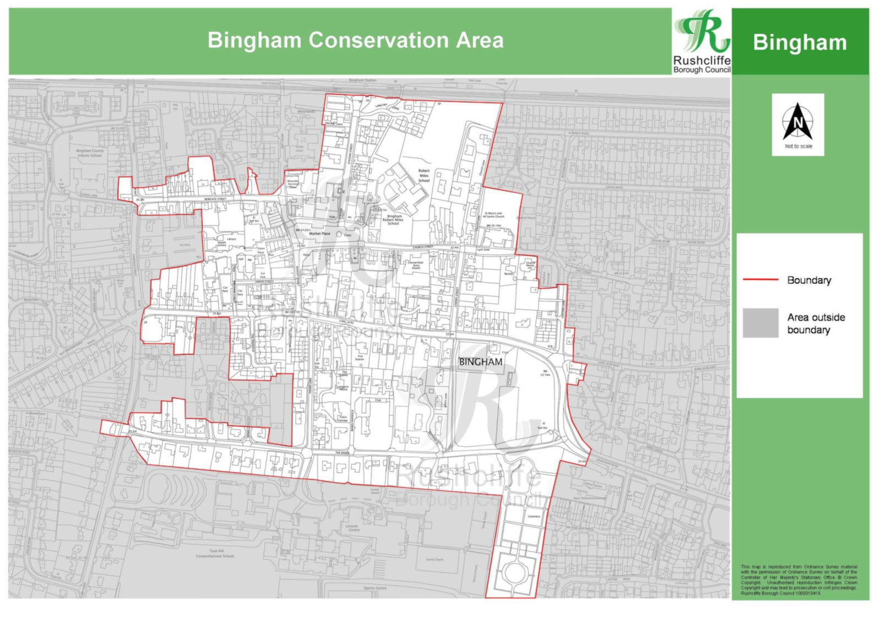

Landmarks, Focal Points and Popular Views
Thinking specifically about the conservation area’s landmarks, focal points and popular views comment on the strengths, weaknesses, opportunities and threats.

You can use the existing boundary as a rough guide when considering the Conservation Area. As you complete the SWOT analysis below, ensure each comment specifies the location which it refers to.
Strengths – What is uniquely positive about the landmarks, focal points and popular views in general? | Weaknesses - What is unfortunately negative about the landmarks, focal points and popular views in general?
Opportunities - What could make the landmarks, focal points and popular views better? | Threats - What could make the landmarks, focal points and popular views better?

Open Spaces, Trees, and Landscape
Thinking specifically about the conservation area’s open spaces, trees and landscape, comment on the strengths, weaknesses, opportunities and threats.

You can use the existing boundary as a rough guide when considering the Conservation Area. As you complete the SWOT analysis below, ensure each comment specifies the location which it refers to.

Strengths - what are the positives of the open spaces, trees, and landscape | Weaknesses - what are the negatives of the open spaces, trees, and landscape
Opportunities – what could make the open spaces, trees, and landscape better? | Threats - what would make an open spaces, trees and landscape worse?

Building types and Activity
Thinking specifically about the conservation area’s building types and activities, comment on the strengths, weaknesses, opportunities and threats.
You can use the existing boundary as a rough guide when considering the Conservation Area. As you complete the SWOT analysis below, ensure each comment specifies the location which it refers to.

Strengths - what activities/places can you go that makes the conservation area within the village/town great? | Weaknesses - what activities/places that exist that detract from making the conservation area within the village/town great?
Opportunities - what activities/places could exist that would the conservation area within the village/town even better? | Threats - what activities/places would make the conservation area within the village/town worse?

Key Characteristics and Building Materials
Thinking specifically about the conservation area’s key characteristics and building materials comment on the strengths, weaknesses, opportunities and threats.

You can use the existing boundary as a rough guide when considering the Conservation Area. As you complete the SWOT analysis below, ensure each comment specifies the location which it refers to.

Strengths – what is it about most existing buildings that looks good? | Weaknesses - what is it about most existing buildings that does not look good?
Opportunities - what could make existing buildings (or new builds) look good and contribute to the character of the area? | Threats - what could make existing buildings (or new builds) look worse and detract from the character of the area?

