Full Council Tuesday 28 June 2022
Community Land
Background
As part of the large-scale development on Chapel Lane, a piece of Community land was allocated. In 2021 Bingham Town Council added an amount of £5000, for architect fees, to the three-year reserves plan. This was to fund architect assistance in progressing potential uses with interested community stakeholders.
Rushcliffe Borough Council has confirmed that:
The offer of the land is to remain open until Occupation of 40% of the Dwellings on Chapel Lane or on the third anniversary of the Occupation of the 101st Dwelling, whichever is the earlier. It is expected that the offer will remain open until mid-2023.
The Community Centre Land is defined as 0.25 ha freehold land upon which the Community Centre may be built as broadly shown below.
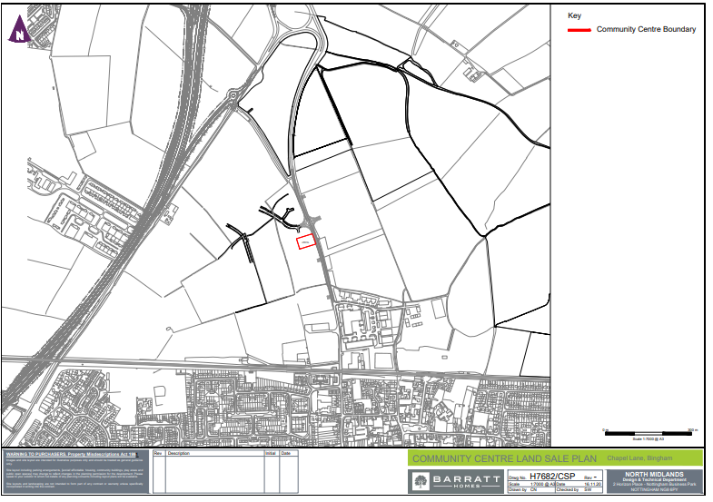
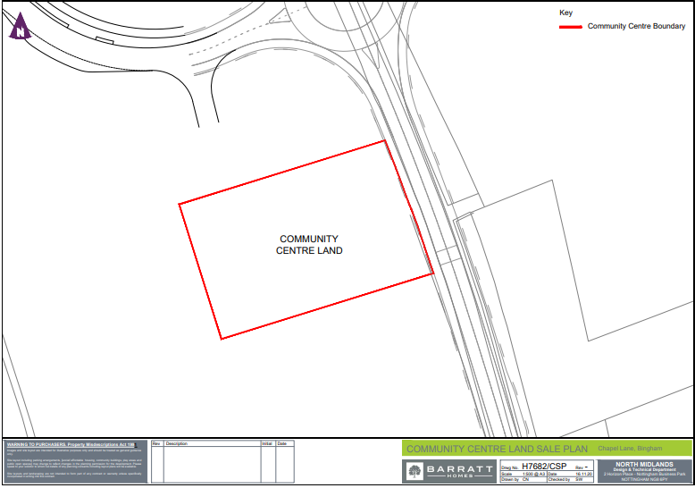
The 106 Agreement specifies that land transfer shall:

Include a restriction in perpetuity in favour of the Owner that the Community Centre Land shall not be used for any purpose other than as a Community Centre;
Reserve such rights and reservations in favour of the retained land as are reasonably necessary as to facilitate the carrying out and future use of the Development in accordance with the Planning Permission, and;
Include a requirement that each party shall bear its own costs associated with the said transfer

There is no requirement under the S106 agreement requiring submission of a scheme for the Community Centre prior to the land transfer. It would be expected, however, that the Town Council would be nominated as the appropriate body for the land to be transferred to. The Town Council would provide information on what project the community seeks to deliver on the Community Land and timescales for delivery.

The new leisure centre will already incorporate a community space, so any duplication between the two sites would need to be avoided to maximise what is on offer for residents.

Meeting with Architect Firms
The Clerk identified three Architects that all had experience with Community projects and met all three companies on site. The firms were all given the information about the land and were asked to provide a quote for leading on engagement to identify community stakeholders and capture the potential uses for the site. The outcome would be a report to Council on the engagement carried out, the community uses identified and the feasibility of the uses identified.

The end report would then be considered by the Town Council for agreement on the next steps.

Quotes

The three quotes identify the steps each firm would use to capture the information and produce a report for consideration.

Quote 1 – £3950

Quote 2 - £5000

Quote 3 - £3100 for the essential work plus the consultation option/options chosen. This would increase the costs anywhere from £3950 to £7250 if all three consultation options were selected.

Recommendation

The Council are asked to consider the quotes, focusing on the need for community engagement to identify the key stakeholders and to capture their requirements.

At the time of writing the report, quote 2 had been asked to clarify how they would carry out their community engagement.

If Councillors have other key questions relating to any quote, please contact the Clerk to seek clarification prior to next Tuesday’s meeting.

