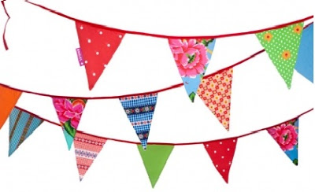

BINGHAM TOWN COUNCIL

To all Charities/Community Groups/Businesses

Bingham Town Fair Saturday 9 June 2018 10am – 5pm

We are looking forward to an even bigger and better event than last year.

This year the Town Fair will be held on the Market Square and Eaton Place. If you would like to join us, please complete and return this booking form as spaces are allocated on a first come, first served basis.

Traditional market stalls are available again this year on the Square and spaces are limited.

8’ x 2’ standing room
8’ x 4’ table top
8’ x 2’ standing room
Market stall dimensions are 8ft square
Layout as per diagram

Space for pitches is available on the Square and Eaton Place.

If you have any queries, please do not hesitate to contact us at the Town Office, (details below).

Further details regarding access, location, programme etc. will be provided nearer the date. Looking forward to meeting you on the day!

Jo Riddle
Deputy Clerk

BINGHAM TOWN FAIR – SATURDAY 9TH JUNE 2018
Business (√) |  |  |  |  | Community Group (√)
Name of Group/Business

Contact Name

Address

Telephone number

Email address

Stall Activity Proposed
(MUST BE COMPLETED)
PAYMENT (please circle payment method)
Cheques:  payable to Bingham Town Council |  |  |  |  | Please insert cheque amount here:
Electronic payment:  Account name: Bingham Town Council  Sort Code: 60-02-41  Account number: 81492286 |  |  |  |  | Please insert your bank details, including account name, here, for account cross referencing purposes:
 | Market Square/Eaton Place  8 foot stall provided |  |  |  |  | Market Square  3 metre pitch |  |  |  | Eaton Place  3 metre pitch
Charities/Community  Groups | Cost  £30 |  | Quantity |  |  | Cost  £20 |  | Quantity |  | Cost  £15 |  | Quantity
Businesses/  Commercial | Cost  £40 |  | Quantity |  |  | Cost  £30 |  | Quantity |  | Cost  £25 |  | Quantity
Electricity required |  |  |  |  | YES |  | NO |  | Appliance/Amperage
Public Liability Insurance |  |  |  |  | YES  Please enclose copy |  | NO
Will you be supplying/selling alcohol? |  |  |  |  | YES |  | NO |  | If yes please contact office for further information
Will you be supplying/selling food? |  |  |  |  | YES |  | NO
If yes, are you registered with your local authority? |  |  |  |  | YES |  | NO |  | Who are you registered with?
FOR BINGHAM TOWN COUNCIL OFFICE USE ONLY
PITCH NO.
ELECTRICAL POST NUMBER

